Maths & Music

DCOM2B R00114193

algorithmic music project

Robert O’riordan

2015

For this project I decided to put together a 39 second track with 140 bpm in 4/4 time. I did this by using the software Logic Express 9 and first creating three different basslines lasting two bars each. Each bassline was made so as to flow into each other smoothly. Next I put together a second track that would serve as the chord progression on top of these basslines. I made three chord sections of the same length for each bassline. Finally, a percussion track was added. I created three different percussion sections of the same length.

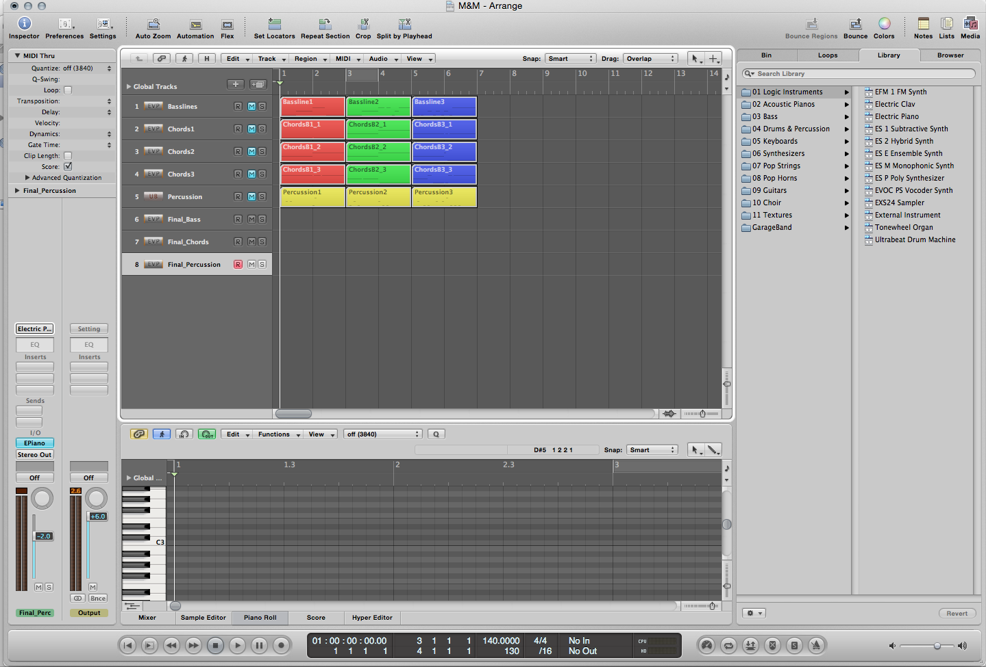

*Screenshot of the Logic Express 9 environment with each of the tracks and sections. The color coding shows which Chord sections apply to each Bassline section. Red is Bassline1, Green is 2, Blue is 3. The yellow is used for Percussion.*

The logic of the song would be that ten sections would be selected, comprised of a randomly selected bassline section and then a randomly selected chord section from the three that apply to that bassline. An entirely random Percussion section would then be chosen from the three available. Finally, a final section combination consisting of a randomly selected bassline and percussion section would close out the song.

To have the randomization be truly accurate, I wrote a short Java program to print out the 11 section combinations to be used. The code can be seen on the following page. Lines in green represent comments explaining each section of code.

**public** **class** test {

**public** **static** **void** main(String[] args) {

//array of the chord sections associated with the first bassline section

String[] b1Chords = {"B1_Chords1", "B1_Chords2", "B1_Chords3"};

//...second bassline section

String[] b2Chords = {"B2_Chords1", "B2_Chords2", "B2_Chords3"};

//...third...

String[] b3Chords = {"B3_Chords1", "B3_Chords2", "B3_Chords3"};

//runs generateSong method below using the above arrays as parameters

*generateSong*(b1Chords, b2Chords, b3Chords);

}

//The algorithmic method takes the arrays in its parameters

**public** **static** **void** generateSong(String[] b1Chords, String[] b2Chords, String[] b3Chords) {

//Goes through the following loop 10 times

**for** (**int** x = 0; x < 10; ++x) {

//Prints a new line to serve as a gap between each printed section

System.*out*.println();

//Number representing what bassline section is used

**int** bassline = 0;

//A randomly chosen bassline from 1 to 3

bassline = *random*() + 1;

//if the the first bassline section is chosen

**if** (bassline == 1) {

//a number representing an array index (generated using random method)

**int** index = *random*();

//The system prints out that index of the chords array associated with bassline 1

System.*out*.print(b1Chords[index]);

}

//else if the the second bassline section is chosen

**else** **if** (bassline == 2) {

//a number representing an array index (generated using random method)

**int** index = *random*();

//The system prints out that index of the chords array associated with bassline 2

System.*out*.print(b2Chords[index]);

}

//else if the the third bassline section is chosen

**else** **if** (bassline == 3) {

//a number representing an array index (generated using random method)

**int** index = *random*();

//The system prints out that index of the chords array associated with bassline 3

System.*out*.print(b3Chords[index]);

}

//Prints a random number from 1 to 3 representing percussion choice beside the chosen chord

System.*out*.print(" Percussion " + (*random*() + 1));

}

//The loop ends here

//Prints gap

System.*out*.println();

//finally, a solo bassline is chosen to end the song

System.*out*.print("Bassline" + (*random*() + 1));

//A percussion track is selected to join it

System.*out*.print(" Percussion " + (*random*() + 1));

}

//Method to generate a random index from 0 to 2

**public** **static** **int** random() {

**return** (**int**) (Math.*random*() * 3);

}

}

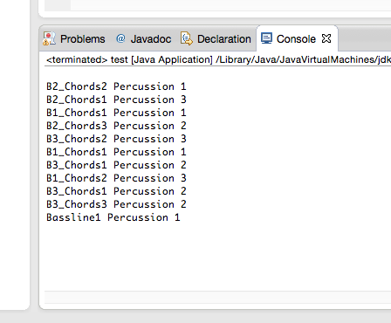

*The console print out from the executed code. B2_Chords2 Percussion 1 would = Bassline Section 2, Chords Section 2, Percussion Section 1.*

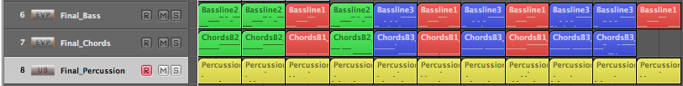

*A screenshot of the final track layout (shrunk down for visibility) in Logic Express 9.*